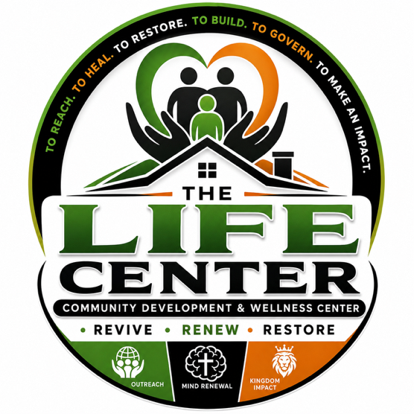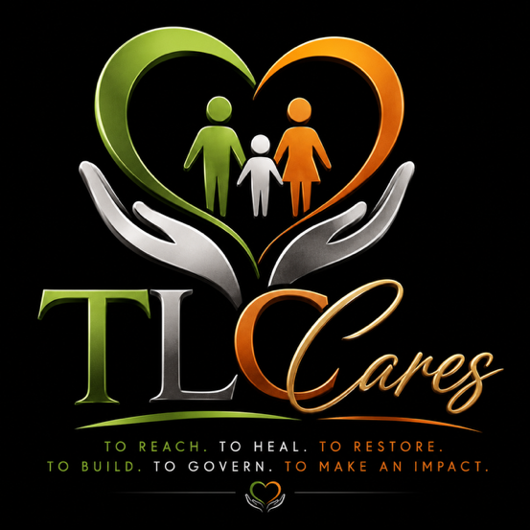

THE LIFE CENTER COMMUNITY DEVELOPMENT & WELLNESS CENTER

Volunteer Application
Thank you for your interest in volunteering with The Life Center Community Development & Wellness Center. Volunteers are an essential part of our mission to restore hope, empower independence, strengthen families, and transform communities. Please complete this application in its entirety.

APPLICANT INFORMATION
Full Name:

Preferred Name (if different):

Date of Birth:
//_________
Address:

City: ______________________
State: ___________
Zip Code: ___________
Phone Number:

Email Address:

Preferred Method of Contact
☐ Phone
☐ Email
☐ Text Message

EMERGENCY CONTACT
Name:

Relationship:

Phone Number:

VOLUNTEER INTERESTS
Please select all areas where you would like to serve.

Community Programs
☐ Community Outreach
☐ Food Distribution
☐ Clothing Drives
☐ Holiday Programs
☐ Resource Fairs
☐ Special Events
☐ Community Clean-Up

Behavioral Health
☐ Reception
☐ Administrative Support
☐ Group Support Assistant
☐ Resource Navigation
☐ Wellness Events

Restoration House
☐ Resident Activities
☐ Meal Preparation
☐ Life Skills Classes
☐ Moving Assistance
☐ House Projects

Administrative
☐ Office Support
☐ Data Entry
☐ Filing
☐ Reception
☐ Phone Calls
☐ Scheduling

Professional Services
☐ Licensed Mental Health Professional
☐ Nurse
☐ Physician
☐ Attorney
☐ Accountant
☐ Grant Writer
☐ Photographer
☐ Videographer
☐ Graphic Designer
☐ Marketing
☐ Information Technology
☐ Maintenance
☐ Construction
☐ Landscaping
☐ Other

AVAILABILITY
Preferred Start Date

How often would you like to volunteer?
☐ Weekly
☐ Bi-Weekly
☐ Monthly
☐ Occasionally
☐ One-Time Events

Days Available
☐ Monday
☐ Tuesday
☐ Wednesday
☐ Thursday
☐ Friday
☐ Saturday
☐ Sunday

Preferred Times
☐ Morning
☐ Afternoon
☐ Evening

EDUCATION & EXPERIENCE
Highest Level of Education
☐ High School
☐ Some College
☐ Associate Degree
☐ Bachelor's Degree
☐ Master's Degree
☐ Doctorate
☐ Trade School

Occupation

Employer (Optional)

Please describe any experience, skills, certifications, or talents that may benefit our organization.

PREVIOUS VOLUNTEER EXPERIENCE
Have you volunteered before?
☐ Yes
☐ No
If yes, please describe.

BACKGROUND INFORMATION
Have you ever been convicted of a felony or misdemeanor (excluding minor traffic violations)?
☐ Yes
☐ No
If yes, please explain.

A criminal conviction does not automatically disqualify an applicant. Each application will be reviewed individually.

DRIVING INFORMATION
Do you possess a valid driver's license?
☐ Yes
☐ No
Would you be willing to drive on behalf of The Life Center if approved?
☐ Yes
☐ No

WHY DO YOU WANT TO VOLUNTEER?
Please tell us why you would like to volunteer with The Life Center Community Development & Wellness Center.

HOW DID YOU HEAR ABOUT US?
☐ Friend
☐ Family
☐ Church
☐ Social Media
☐ Community Event
☐ Website
☐ Google Search
☐ Other

VOLUNTEER ACKNOWLEDGMENT
I certify that the information provided in this application is true and complete to the best of my knowledge.
I understand that submission of this application does not guarantee acceptance as a volunteer.
If accepted, I agree to:
- Conduct myself professionally and respectfully.
- Maintain confidentiality regarding information obtained while volunteering.
- Follow all organizational policies and procedures.
- Promote a safe, welcoming, and inclusive environment.
- Report concerns or incidents promptly.
- Complete any required orientation or training before beginning volunteer service.
I understand that volunteer service may be discontinued by either party at any time.

Applicant Signature

Date

OFFICE USE ONLY
Date Application Received

Interview Completed
☐ Yes
☐ No
Background Check Required
☐ Yes
☐ No
Reference Check Completed
☐ Yes
☐ No
Orientation Completed
☐ Yes
☐ No
Volunteer Approved
☐ Yes
☐ No
Volunteer Assignment

Supervisor

Start Date

When completed please email to lfghotmfellowship@outlook.com

